Module 3: Seatback Storage Sack

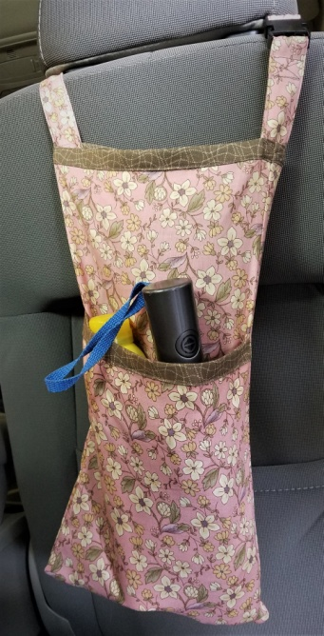

- 1 yard of 44/45” medium weight cotton fabric for sack
- ¼ yard of 44/45” contrasting medium weight cotton fabric for binding
- 1 spool of coordinating all-purpose thread
- One 1” parachute buckle (sometimes called a quick-release clip)

