Module 4: Apron

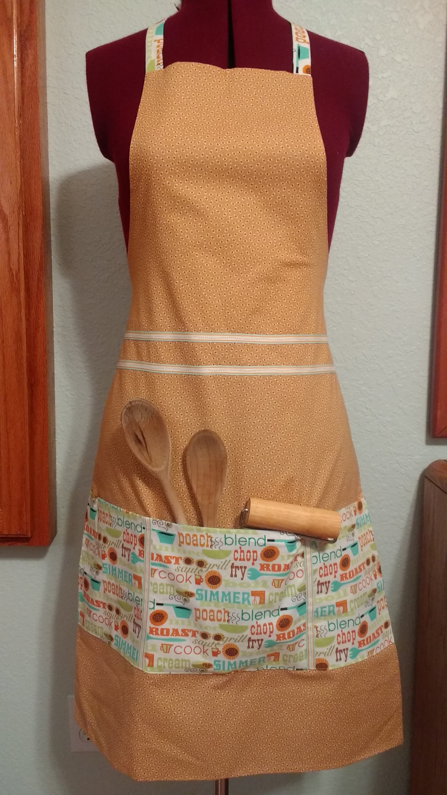

- 1 yard medium weight woven cotton (nothing stretchy) for front
- 1 yard light weight woven cotton (nothing stretchy) for back
- ½ yard woven cotton (nothing stretchy) for pocket
- One spool all-purpose thread to blend with chosen fabrics

