Module 5: Skirt
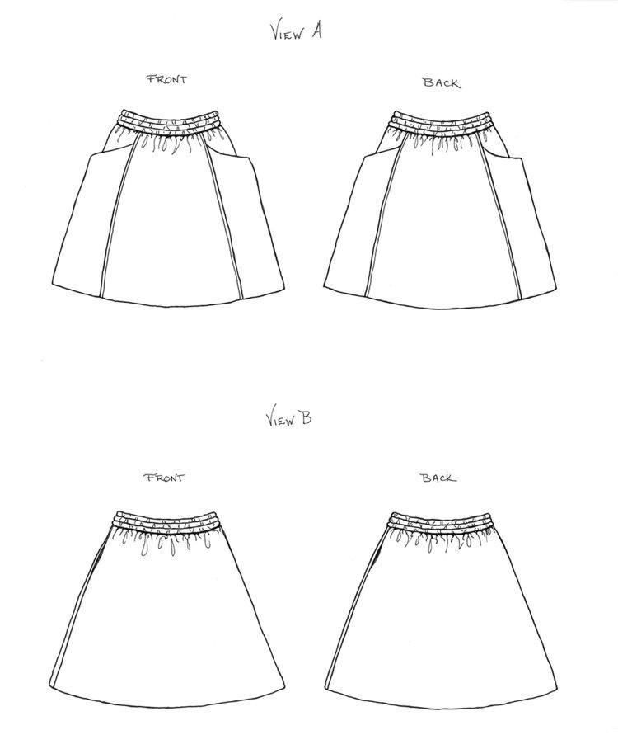

We will be making view B in Learn to Sew Boot Camp Module 5

- 3 ½ yards of 45” wide woven fabric (nothing stretchy) such as lightweight denim, mid-weight linen, double gauze, cotton ikat
- Wash, dry and press fabric before coming to sewing boot camp
- 1 ½ yards of 2” wide soft waistband elastic
- One spool of all-purpose thread to blend with fabric color

