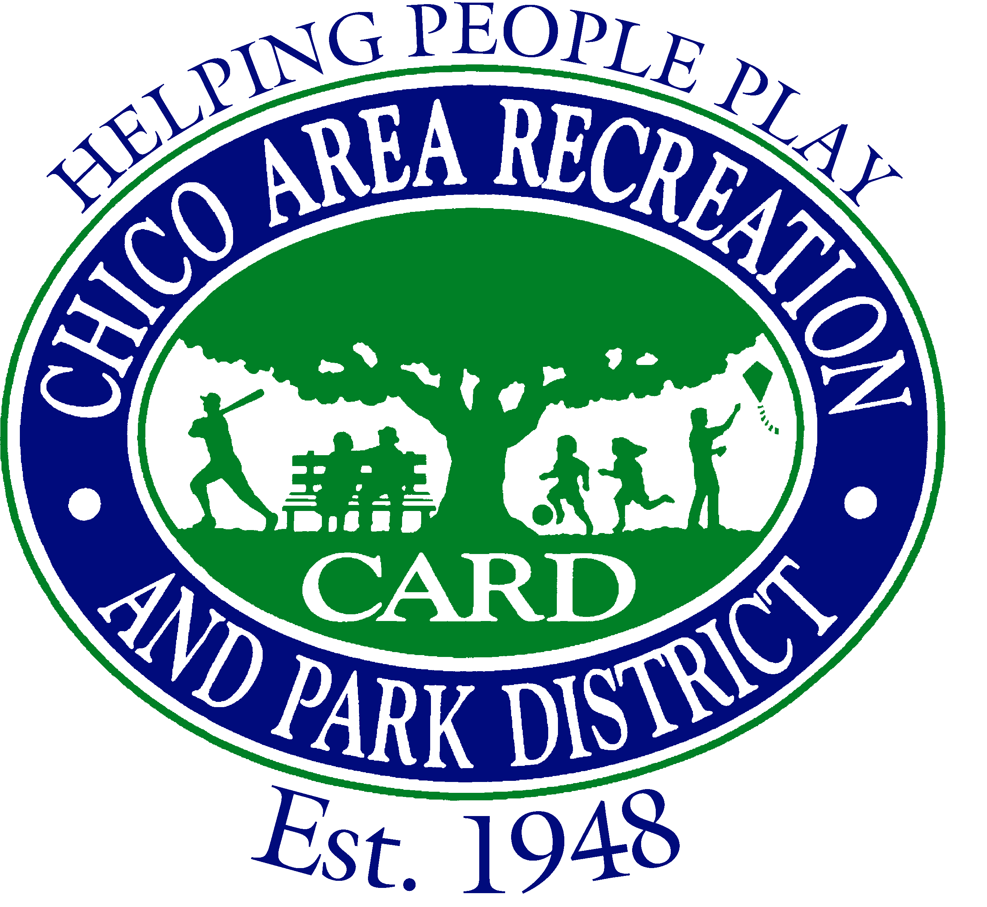
Chico Area Recreation and Park District “Helping People Play”

Application for Appointment
to a Special District Vacancy

Instructions
If you are interested in serving on a Special District Board of Directors, please complete this application and return it to:

Chico Area Recreation and Park District (CARD)
c/o Steve Visconti, General Manager
545 Vallombrosa Avenue, Chico, CA 95926

All applications are due by September 28, 2012, by 5:00 p.m. You must attend the Special Board Meeting of the Chico Area Recreation and Park District on October 11, 2012, at 6:00 p.m., at the CARD Community Center, 545 Vallombrosa Avenue, Chico, California. At that time, you will be advised by the District Board if your appointment is confirmed.

Name:________________________________________ Date:_________________

Residence Address:____________________________________________________

Business or Mailing Address:_____________________________________________

Phone (Daytime) _______________________ (Evening) _____________________
WORK/VOLUNTEER EXPERIENCE
Organization | City | Position | From | To
EDUCATION
Institution | Major | Degree | Years Attended

Statement of Qualifications:

Please briefly describe your qualifications and why you are interested in serving on the Board of Directors.

Certification:

I certify that the information contained in this application is true and correct. I authorize the verification of the information in this application.

________________________________ _____________________
Signature Date

