Module 2: Market Tote

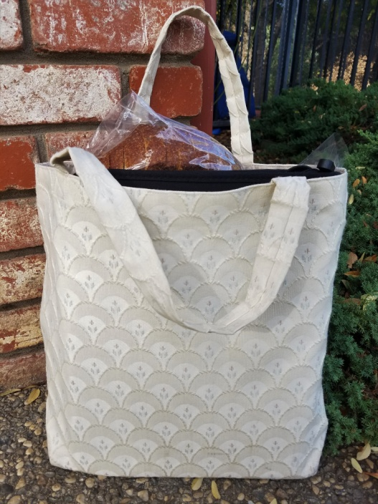

- 1 ¼ yard of 44/45” sturdy weight cotton fabric for bag exterior and straps
- 1 yard of 44/45” coordinating cotton fabric for lining
- 1 spool coordinating all-purpose thread

